**Star Schema Data Warehouse Implementation**

# **Objective**

To design and implement a star schema in PostgreSQL that supports analytical queries on a retail sales dataset downloaded from Kaggle. This includes creating normalized dimension tables and a centralized fact table for efficient querying and reporting.

# **Dataset Overview**

**Source File:** retail_sales_dataset.csv

Fields:

* - Transaction_ID: Unique transaction ID
* - Date: Transaction date
* - Customer_ID: Unique ID of the customer (e.g., CUST001)
* - Gender: Gender of the customer
* - Age: Age of the customer
* - Product_Category: Category of product sold
* - Quantity: Number of units sold
* - Price_Per_Unit: Price of a single unit

# **Schema Design**

**The star schema consists of the following tables:**

1. Fact Table: fact_sales

* - transaction_id (Primary Key)
* - date_key (FK to dim_date)
* - customer_key (FK to dim_customer)
* - product_key (FK to dim_product)
* - quantity
* - price_per_unit
* - total_amount

2. Dimension Table: dim_date

* - date_key (Primary Key)
* - date
* - day
* - month
* - year
* - quarter

3. Dimension Table: dim_customer

* - customer_key (Primary Key)
* - customer_id
* - gender
* - age

4. Dimension Table: dim_product

* - product_key (Primary Key)
* - product_category

# **Implementation Steps**

**1. Database Creation**

CREATE DATABASE retail_dw OWNER postgres;

**2. Schema & Table Setup**

CREATE SCHEMA IF NOT EXISTS star;

SET search_path = star;

**Staging table for raw CSV**

CREATE TABLE IF NOT EXISTS staging_sales (  
 transaction_id INTEGER,  
 date DATE,  
 customer_id VARCHAR(20),  
 gender VARCHAR(10),  
 age INTEGER,  
 product_category VARCHAR(50),  
 quantity INTEGER,  
 price_per_unit NUMERIC(10,2),  
 total_amount NUMERIC(10,2)  
);

**Dimension Tables**

CREATE TABLE IF NOT EXISTS dim_date (  
 date_key INTEGER PRIMARY KEY,  
 date DATE NOT NULL,  
 day SMALLINT NOT NULL,  
 month SMALLINT NOT NULL,  
 year INTEGER NOT NULL,  
 quarter SMALLINT NOT NULL  
);

CREATE TABLE IF NOT EXISTS dim_customer (  
 customer_key SERIAL PRIMARY KEY,  
 customer_id VARCHAR(20) UNIQUE,  
 gender VARCHAR(10),  
 age INTEGER  
);  
  
CREATE TABLE IF NOT EXISTS dim_product (  
 product_key SERIAL PRIMARY KEY,  
 product_category VARCHAR(50) UNIQUE  
);

**Fact Table**

CREATE TABLE IF NOT EXISTS fact_sales (  
 transaction_id INTEGER PRIMARY KEY,  
 date_key INTEGER NOT NULL REFERENCES dim_date(date_key),  
 customer_key INTEGER NOT NULL REFERENCES dim_customer(customer_key),  
 product_key INTEGER NOT NULL REFERENCES dim_product(product_key),  
 quantity INTEGER,  
 price_per_unit NUMERIC(10,2),  
 total_amount NUMERIC(10,2)  
);

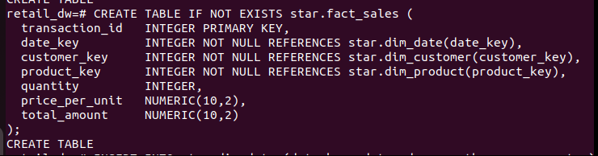

**3. Data Import Using \copy**

\copy star.staging_sales(transaction_id, date, customer_id, gender, age, product_category, quantity, price_per_unit, total_amount)  
FROM '/home/rishabh/task/star_schema/retail_sales_dataset.csv'  
WITH (FORMAT csv, HEADER true);

## **4. Populating Dimension Tables**

**dim_date:**

INSERT INTO dim_date (date_key, date, day, month, year, quarter)  
SELECT DISTINCT  
 EXTRACT(YEAR FROM date)::INT * 10000 +  
 EXTRACT(MONTH FROM date)::INT * 100 +  
 EXTRACT(DAY FROM date)::INT AS date_key,  
 date,  
 EXTRACT(DAY FROM date)::SMALLINT,  
 EXTRACT(MONTH FROM date)::SMALLINT,  
 EXTRACT(YEAR FROM date)::INT,  
 EXTRACT(QUARTER FROM date)::SMALLINT  
FROM star.staging_sales  
ON CONFLICT (date_key) DO NOTHING;

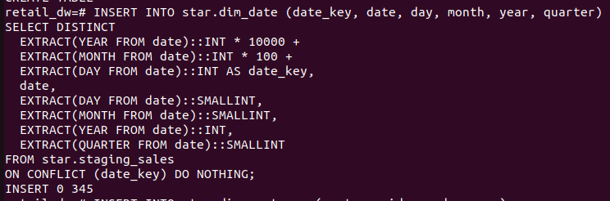

**dim_customer:**

INSERT INTO dim_customer (customer_id, gender, age)  
SELECT DISTINCT customer_id, gender, age  
FROM star.staging_sales  
ON CONFLICT (customer_id) DO NOTHING;

**dim_product:**

INSERT INTO dim_product (product_category)  
SELECT DISTINCT product_category  
FROM star.staging_sales  
ON CONFLICT (product_category) DO NOTHING;

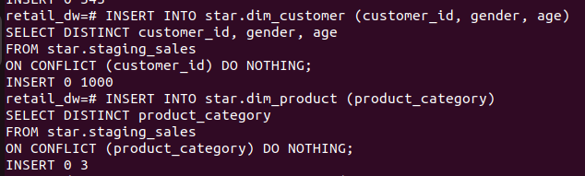

**5. Populating Fact Table**

INSERT INTO fact_sales (transaction_id, date_key, customer_key, product_key, quantity, price_per_unit, total_amount)  
SELECT  
 s.transaction_id,  
 EXTRACT(YEAR FROM s.date)::INT * 10000 +  
 EXTRACT(MONTH FROM s.date)::INT * 100 +  
 EXTRACT(DAY FROM s.date)::INT AS date_key,  
 c.customer_key,  
 p.product_key,  
 s.quantity,  
 s.price_per_unit,  
 s.total_amount  
FROM star.staging_sales s  
JOIN dim_customer c ON s.customer_id = c.customer_id  
JOIN dim_product p ON s.product_category = p.product_category;

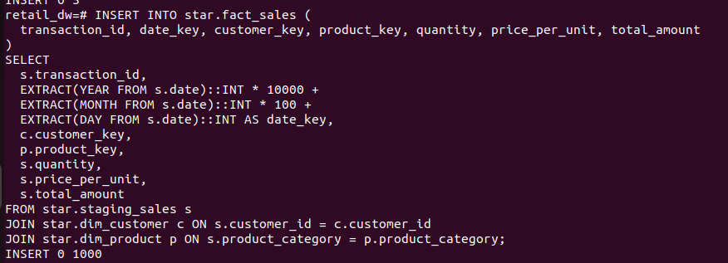

**Validation & Testing**

**Check row counts:**

SELECT   
 (SELECT COUNT(*) FROM star.dim_date) AS dim_date_rows,  
 (SELECT COUNT(*) FROM star.dim_customer) AS dim_customer_rows,  
 (SELECT COUNT(*) FROM star.dim_product) AS dim_product_rows,  
 (SELECT COUNT(*) FROM star.fact_sales) AS fact_sales_rows;

**Sample join query:**

SELECT   
 f.transaction_id,   
 d.date,   
 c.customer_id,   
 p.product_category,   
 f.quantity,   
 f.total_amount  
FROM star.fact_sales f  
JOIN star.dim_date d ON f.date_key = d.date_key  
JOIN star.dim_customer c ON f.customer_key = c.customer_key  
JOIN star.dim_product p ON f.product_key = p.product_key  
LIMIT 5;

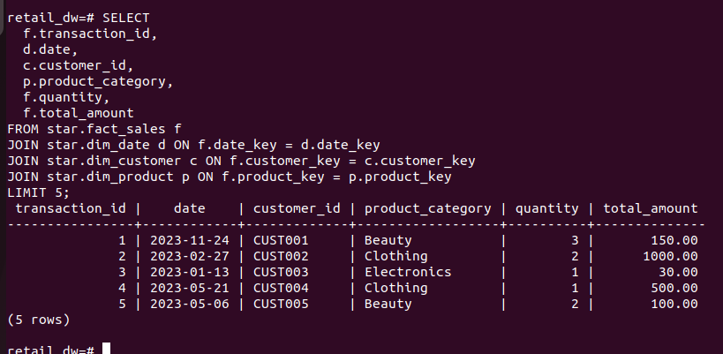

**Outcome**

• Star schema successfully implemented with normalized dimensions.  
• Referential integrity established via foreign keys.  
• Dataset prepared for analytical workloads, dashboards, or BI tools.